**DAY2 JAVA:6/5/25**

**Constructor:**

* Use to initialize the object
* For every class there will be a default constructor
* Whenever we create an object, Constructor will be called.
* Constructor having class-name on method properties.

For constructor:

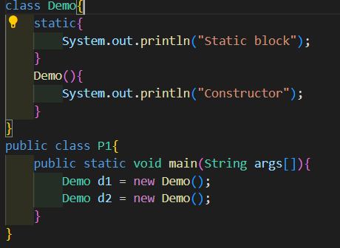

* We created 2 objects, so 2 times constructor will be called.

**static:**

* static Block Created using static keyword.
* It will be called automatically.
* No need to call using object, class.

**static Method ():**

* No need to call using object.
* Call using class-name.
* Here, static will act as instance.